Choi Tim Anthony Young

Dimitri Garcia

Laurice Sattouf

ECE4304- Lab 2

2/16/2021

Professor M. Aly

**Implementing**

**Generic DecoderNx2N using Decoder2x4**

**Purpose:**

* The purpose of this lab is to implement the generic DecoderNx2N using Decoder2x4 in VHDL.
* The dec 2x4 is the base component that we used to generate the rest of the decoder using the generic and for generate instructions in the RTL design.
* The decoders will be places into layers of decoders.
* Our implementation includes a clk and rst to minimize the power used within each cycle.

**Coding steps:**

1. Create the base component Dec2x4.
2. Create the desired entity Dec 5x2N.
3. Use “for generate” to generate the layers of decoders to connect the network of decoders.
4. Use the testbench to verify the results using the textio.

For this lab, we are asked to use the textio Library in order to import inputs to the test bench and save the outputs into a separate txt file.

**Schematic from Vivado:**

Schematic of Decoder 6x64 using Vivado.

**Power and resources used:**

21 look up tables was used with total energy of 3.098:

Our design on the FBGA implemented only Decoder 5x32, but our code makes a design of 6x64 where half of the implemented decoders will not be used.

**Test bench screenshot:**

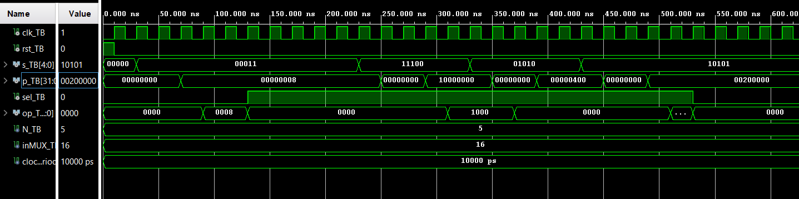

Some values that we tested in VIVADO.

**Difficulties:**

In order to make this lab works without any extra wiring and implementation, we searched out the “If Generate” syntax which will make our design way more valuable and convenient. But we did not use it since it was not part of our learned syntax so far.

In order to cover all the corner cases, we create a test bench script to generate random inputs, and we used that to test as much data as possible.

**Work Contribution:**

* We all worked individually on the code and then we had a discussion session to combine all the work:
  + Anthony mainly worked on the nested loop, the decoder layers fully, and the script for the input file.
  + Dimitri worked on connecting the Mux to the design, creating testbench.
  + Laurice did a different implementation to avoid creating extra Decoders in Anthony’s code, but it was not successful. Plus, the textio file for testing.
* We had a zoom meeting to demo and cover all the corner cases.
* Documentation and reports were evenly distributed, and it covered all the steps of our successfully implemented design.